**ASSIGNMENT 6**

**1. Find the Armstrong Number between the two numbers which are input by user.**

**Code:**

'''

Print Armstrong Numbers between two given numbers

Author: Akshay Sorathia

Date: 12/04/2020

'''

lower=int(input("Python Code print Armstrong Numbers between any two given numbers.\nAuthor: Akshay Sorathia\n\nPlease enter the lower limit: "))

upper = int(input("Please enter the upper limit: "))

arm_nos=[]

for num in range(lower,upper + 1):

sum = 0

temp = num

while temp > 0:

digit = temp % 10

sum += digit ** 3

temp //= 10

if num == sum:

arm_nos.append(num)

print("\nThe armstrong Numbers between "+str(lower)+" and "+str(upper)+" are:")

for i in arm_nos:

print(i))

**Output:**

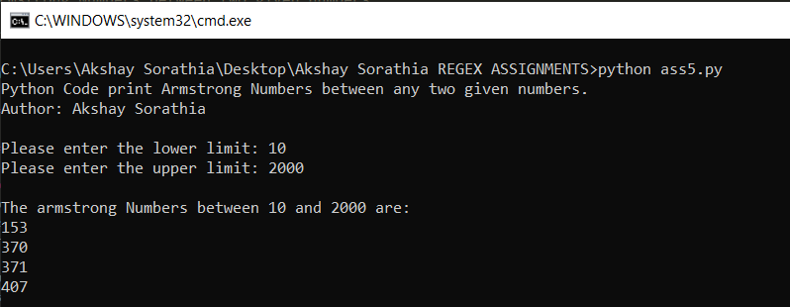

**2. Remove the punctuation like [“@!#$%&*()”] from the string and output the string without them.**

**Code:**

'''

Remove all punctuations from entered string.

Author: Akshay Sorathia

Date: 12/04/2020

'''

punc = '''!()-[]{};:'"\\,<>./?@#$%^&*_~'''

my_str=input("Python Code to remove all punctuations from entered string.\nAuthor: Akshay Sorathia\n\nPlease enter the String: ")

no_punc = ""

for char in my_str:

if char not in punc:

no_punc = no_punc + char

print(no_punc)

**Output:**

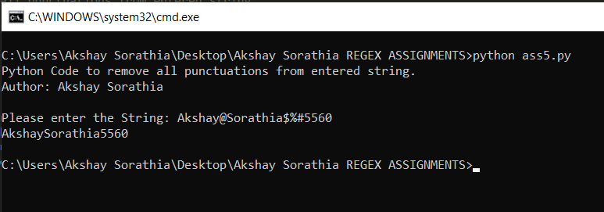

**3. Sort the list of words in Alphabetical order.**

**Code:**

'''

Sort the given list of words

Author: Akshay Sorathia

Date: 12/04/2020

'''

my_str=print("Python Code to sort the given list.\nAuthor: Akshay Sorathia")

my_str = ['Apple', 'banana', 'cat', 'REGEX','apple'] #given

sorted_str=sorted(my_str)

print("\nThe given list is: ",my_str)

print("\nThe Sorted List is: ",sorted_str)

**Output:**

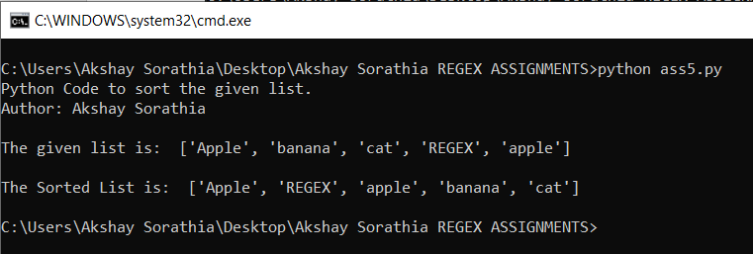

**Reason for such sort:**

* The reason for this type of order is due the ASCII value. For capital letters its starts from 65 whereas for small letters it starts from 97.